# **ASSIGNMENT (22-08-2025)**

**Submitted by: Srividya Arul Raju**

**Roll number: 23KQ5A0206(EEE-A)**

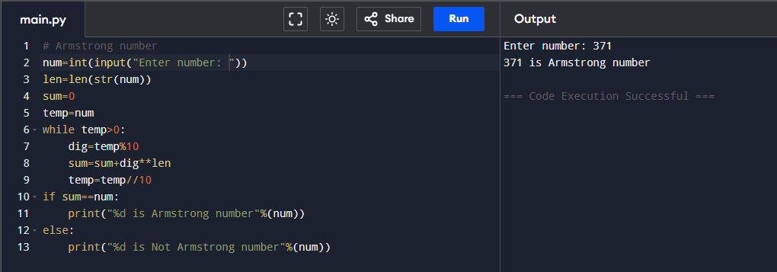1.To check wheather the given number is Armstrong or not in Python.

2.To check the fibnocci series upto nth term.

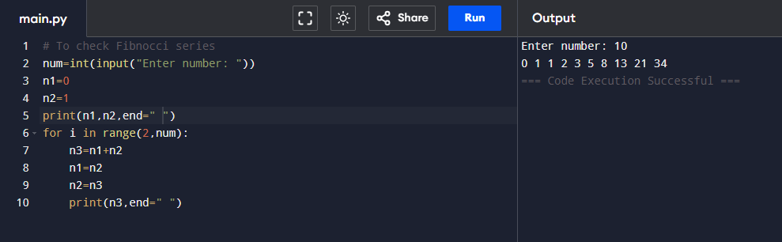

3. To check factorial on given number.

